**Lab Guide**

Dashboards in IBM RPA

Nigel T. Crowther

ncrowther@uk.ibm.com

Hands-on Lab

Version 1.0 for General Availability



NOTICES

This information was developed for products and services offered in the USA.

IBM may not offer the products, services, or features discussed in this document in other countries. Consult your local IBM representative for information on the products and services currently available in your area. Any reference to an IBM product, program, or service is not intended to state or imply that only that IBM product, program, or service may be used. Any functionally equivalent product, program, or service that does not infringe any IBM intellectual property right may be used instead. However, it is the user's responsibility to evaluate and verify the operation of any non-IBM product, program, or service.

IBM may have patents or pending patent applications covering subject matter described in this document. The furnishing of this document does not grant you any license to these patents. You can send license inquiries, in writing, to:

IBM Director of Licensing

IBM Corporation

North Castle Drive, MD-NC119

Armonk, NY 10504-1785

United States of America

The following paragraph does not apply to the United Kingdom or any other country where such provisions are inconsistent with local law: INTERNATIONAL BUSINESS MACHINES CORPORATION PROVIDES THIS PUBLICATION "AS IS" WITHOUT WARRANTY OF ANY KIND, EITHER EXPRESS OR IMPLIED, INCLUDING, BUT NOT LIMITED TO, THE IMPLIED WARRANTIES OF NON-INFRINGEMENT, MERCHANTABILITY OR FITNESS FOR A PARTICULAR PURPOSE. Some states do not allow disclaimer of express or implied warranties in certain transactions, therefore, this statement may not apply to you.

This information could include technical inaccuracies or typographical errors. Changes are periodically made to the information herein; these changes will be incorporated in new editions of the publication. IBM may make improvements and/or changes in the product(s) and/or the program(s) described in this publication at any time without notice.

Any references in this information to non-IBM websites are provided for convenience only and do not in any manner serve as an endorsement of those websites. The materials at those websites are not part of the materials for this IBM product and use of those websites is at your own risk.

IBM may use or distribute any of the information you supply in any way it believes appropriate without incurring any obligation to you.

Information concerning non-IBM products was obtained from the suppliers of those products, their published announcements or other publicly available sources. IBM has not tested those products and cannot confirm the accuracy of performance, compatibility or any other claims related to non-IBM products. Questions on the capabilities of non-IBM products should be addressed to the suppliers of those products.

This information contains examples of data and reports used in daily business operations. To illustrate them as completely as possible, the examples include the names of individuals, companies, brands, and products. All of these names are fictitious and any similarity to the names and addresses used by an actual business enterprise is entirely coincidental.

**TRADEMARKS**

IBM, the IBM logo, and ibm.com are trademarks or registered trademarks of International Business Machines Corp., registered in many jurisdictions worldwide. Other product and service names might be trademarks of IBM or other companies. A current list of IBM trademarks is available on the web at “Copyright and trademark information” at www.ibm.com/legal/copytrade.shtml.

Adobe, the Adobe logo, PostScript, and the PostScript logo are either registered trademarks or trademarks of Adobe Systems Incorporated in the United States, and/or other countries.

Cell Broadband Engine is a trademark of Sony Computer Entertainment, Inc. in the United States, other countries, or both and is used under license therefrom.

Intel, Intel logo, Intel Inside, Intel Inside logo, Intel Centrino, Intel Centrino logo, Celeron, Intel Xeon, Intel SpeedStep, Itanium, and Pentium are trademarks or registered trademarks of Intel Corporation or its subsidiaries in the United States and other countries.

IT Infrastructure Library is a Registered Trade Mark of AXELOS Limited.

ITIL is a Registered Trade Mark of AXELOS Limited.

Java and all Java-based trademarks and logos are trademarks or registered trademarks of Oracle and/or its affiliates.

Linear Tape-Open, LTO, the LTO Logo, Ultrium, and the Ultrium logo are trademarks of HP, IBM Corp. and Quantum in the U.S. and other countries.

Linux is a registered trademark of Linus Torvalds in the United States, other countries, or both.

Microsoft, Windows, Windows NT, and the Windows logo are trademarks of Microsoft Corporation in the United States, other countries, or both.

UNIX is a registered trademark of The Open Group in the United States and other countries.

© Copyright International Business Machines Corporation 2020.

This document may not be reproduced in whole or in part without the prior written permission of IBM.

US Government Users Restricted Rights - Use, duplication or disclosure restricted by GSA ADP Schedule Contract with IBM Corp.

**Table of Contents**

1 Introduction 4

1.1 What is the difference between Dashboards and Reporting? 4

1.2 Prerequisites 5

Scenario - Refund Report 6

1.3 Scenario Description 6

1.4 Start 6

1.5 Log In 6

1.6 Create and Assign developer Role 6

1.7 Publish script 9

1.8 Enter Scripts Menu 9

1.9 Enter Projects Panel 9

1.10 Run the Refunds bot 11

1.11 Enter Dashboard Menu 11

1.12 Create a Refund Status Dashboard 12

1.13 Adding a date filter 15

1.14 Export Dashboard to PDF 17

# Introduction

In this lab we implement a Dashboard for the refund bot created in the Bot Design Lab.

The context of this lab is shown in the highlighted area below.

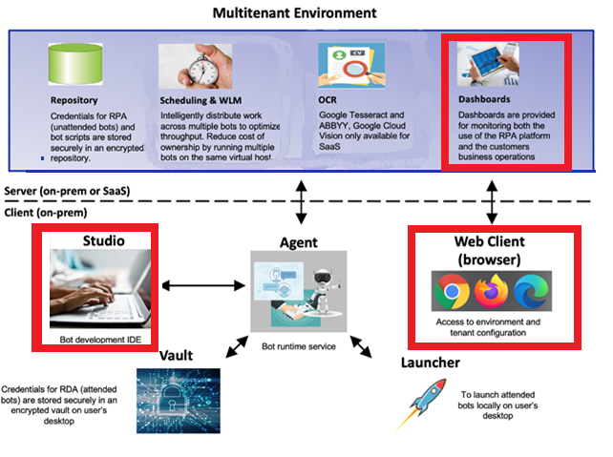

## What is the difference between Dashboards and Reporting?

It is important to distinguish between RPA Dashboards and RPA Reporting. Outwardly they have similar functionality- to create charts from data. But they serve two distinct purposes. Reports are normally customer focused and Dashboards are normally administration focused. In other words, reports are created for end users and dashboards are used by administrators to resolve problems with bots.

The IBM RPA Dashboard can read data from three sources:

* Jobs
* Counters
* Workflows and Processes

In this lab we will examine Counters. For a tutorial on all aspects of the Dashboard, see <https://learn.ibm.com/course/view.php?id=9051>

In this lab we use counters to graph the state of the Refunds bot.

## Prerequisites

To run this lab, you will need to have the Refunds bot ready in RPA Studio. See Bot Design – Lab Guide.

# Scenario - Refund Report

We will create a dashboard to show the counters of the Refund bot.

## Scenario Description

Jon is an RPA administrator responsible for monitoring the refund bot. At end of the day, he sends a pdf to his manager to indicate whether the bot has met its SLA (service level agreement). He exports a pie chart to show refunds in the following states:

* Backend Error
* BotError
* InvalidAmount
* InvalidPaymentType
* InvalidTicket
* Success

## Start

Open the Firefox Browser and navigate to the RPA tenant. If you are using the Skytap image, the URL is <https://localhost:20000/#/en-US/account/login>

## Log In

Login with your username and password. If you are using the SkyTap image, it is

[*admin@ibmdba.com*](mailto:admin@ibmdba.com) */ passw0rd*

## Create and Assign developer Role

By default, the admin user does not have a developer role. In this step we will create and assign this role

In the tenant main menu bar, click on *Access*:

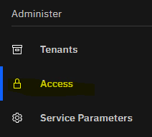

Now click on Teams:

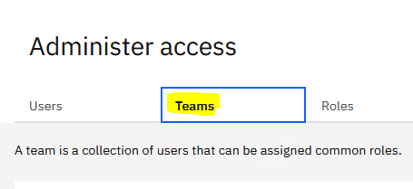

Click the *Create team* button:

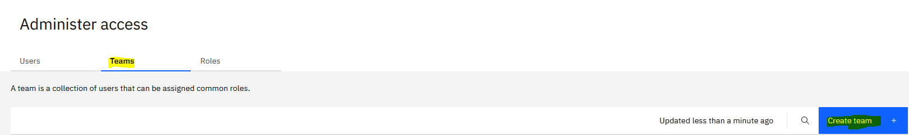

Create the Developer Team:

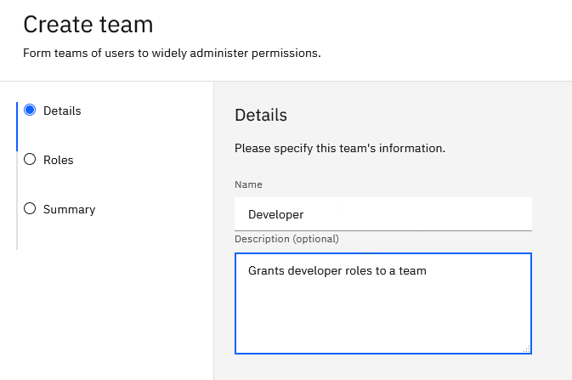

Click *Next*

Click Bot Developer as the Role

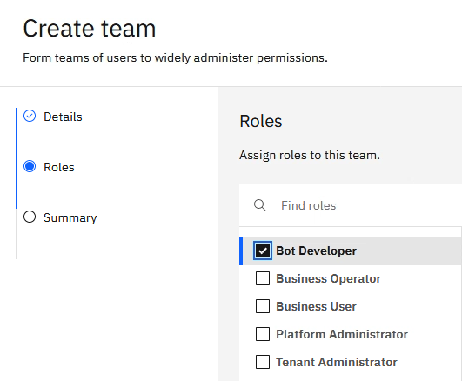

Click *Next* and then *Create.*

Click on the newly created Developer Team and press *Manage users*

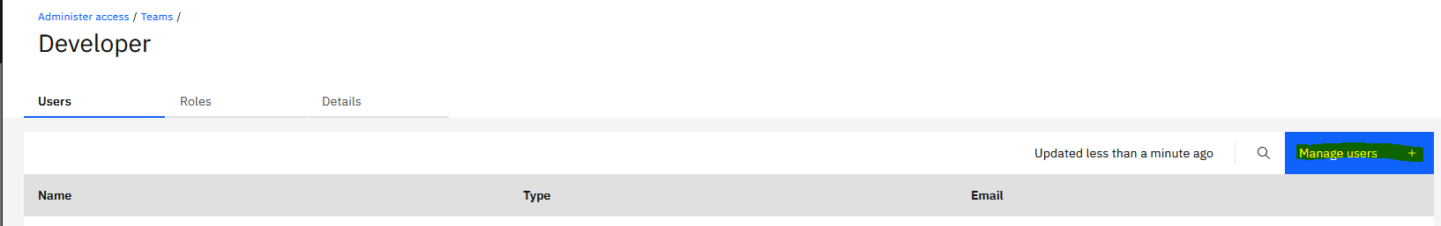

Select Admin:

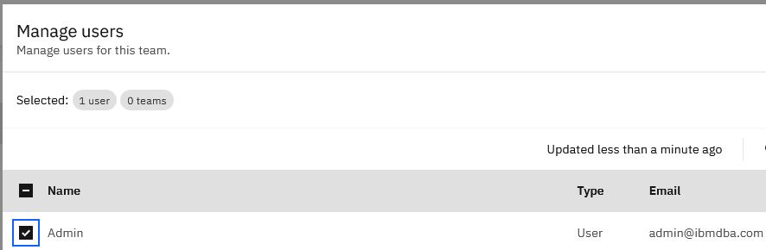

Press *Save*. The admin users now has developer rights.

## Publish script

From RPA Studio, publish the *Refunds_Main_Complete* script from the Bot Design Lab:

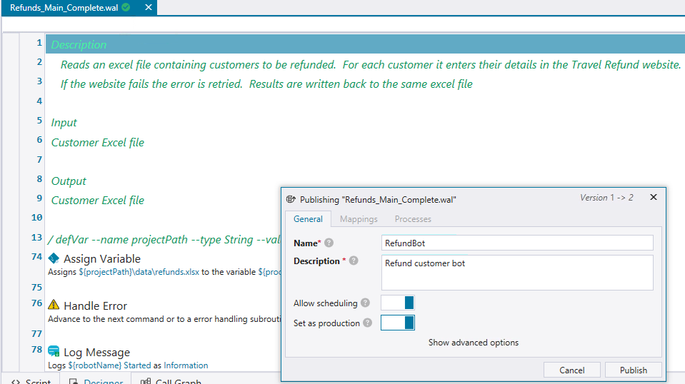

## Enter Scripts Menu

Back in the RPA Web Console, click *Scripts*:

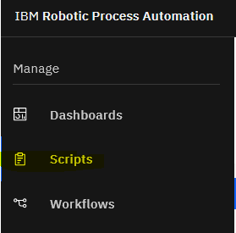

## Enter Projects Panel

Click the *Projects* tab within *Manage* *Scripts*, and select *Create Project*:

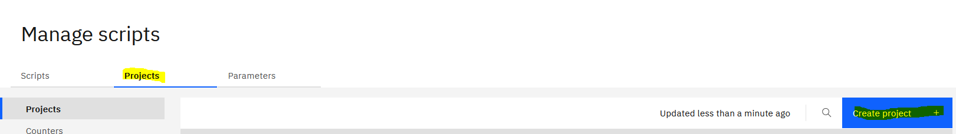

Enter *Refunds* as the name of the project, enter an optional description and then press *Create*

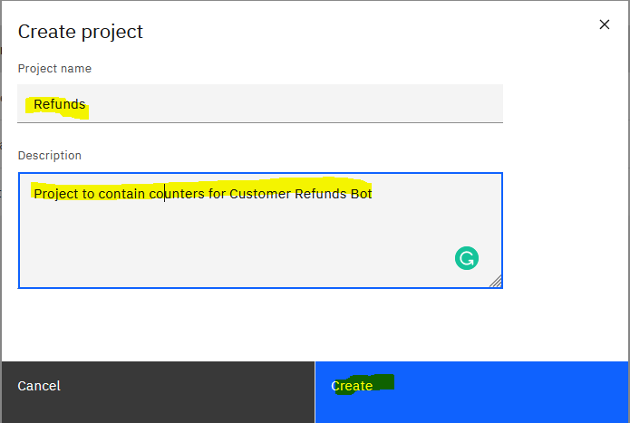

Still in the Projects tab, select *Counters* and then press *Create Counter*:

Create the six counters as shown below:

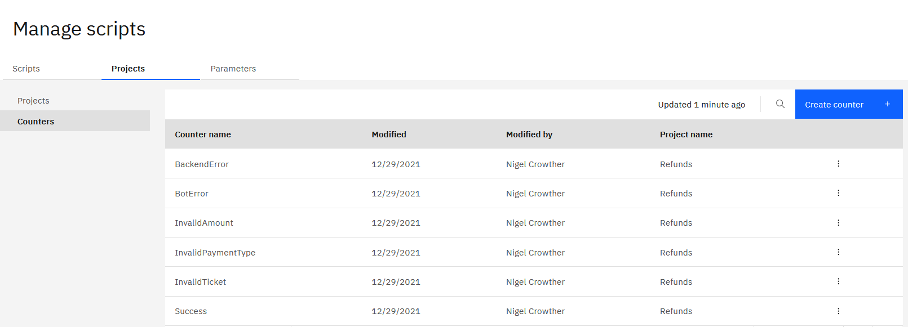

## Run the Refunds bot

Run *[Project_path]/Artefacts*/*Refunds_Main_Complete.wal* implemented in the Bot Design Lab. It should run without errors and increment the counters.

## Enter Dashboard Menu

Back in the tenant main menu, Click *Dashboards*:

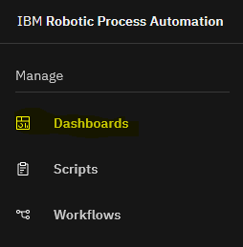

## Create a Refund Status Dashboard

In the Dashboards menu, create a new dashboard. Press *Edit in Designer*.

Click *create*:

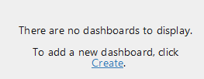

Set the Dashboard Name to *Bot Status*

Choose the data source to *Default* and then press *Create*.

Go back to the Dashboard main menu and select the report you just created.

Click Edit in Designer.

Click the *Pie* icon:

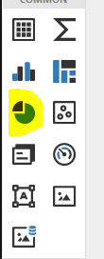

Click on the *Click here* link to bind the chart to the counters data source:

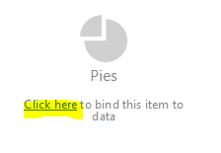

At the bottom of the data selection panel, set the data source to *Counters* and then press *OK*:

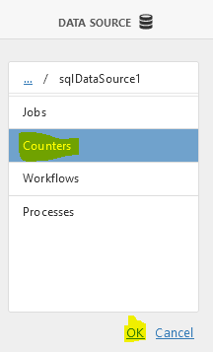

Click on the *Click here* link again, this time to bind data:

Configure the chart data values. Set as follows:

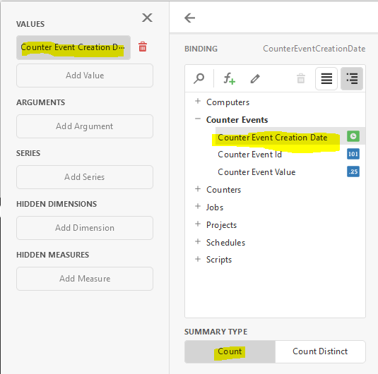

Next set the Arguments (or the name of the segments):

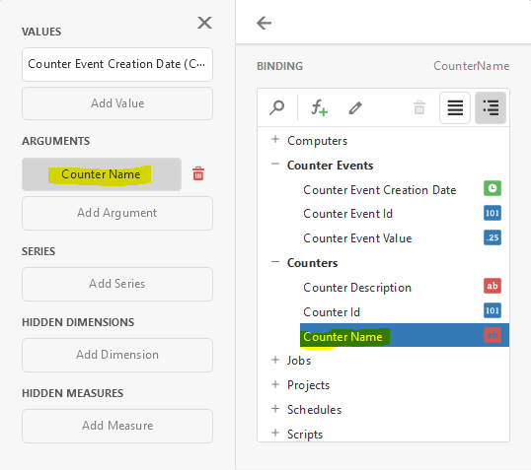

Now add a Hidden Dimension *Counter Event Creation Date*. Ensure it is in *day–month–year* format:

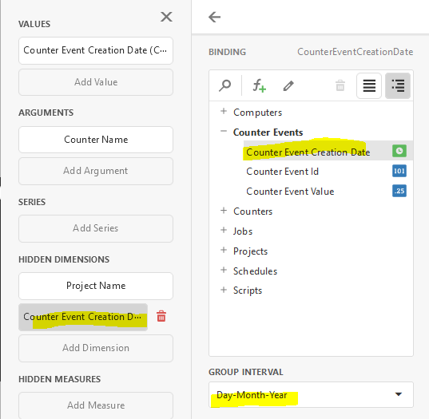

Examine the chart you created. You should see a chart like this:

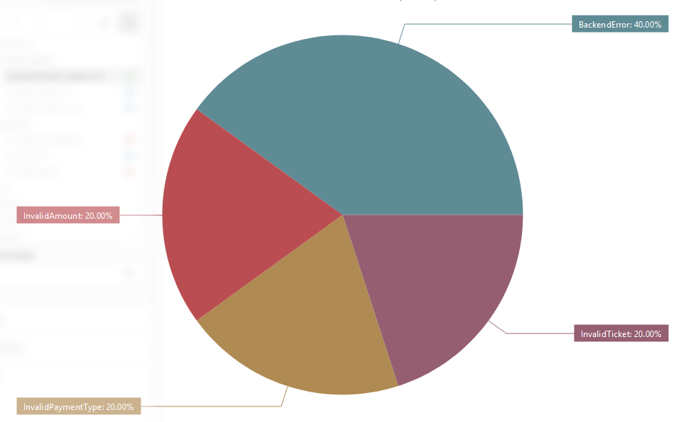

## Adding a date filter

The pie chart shows all counters since the beginning of time. We need to add a filter to make it display the counters from today only. Press the filter icon:



In the filter panel, click the pen icon and set the filter query. Enable the *Advanced Mode* check box and then paste the following condition:

IsOutlookIntervalToday([Counter Event Creation Date (Day-Month-Year)])

You filter dialog should look like this:

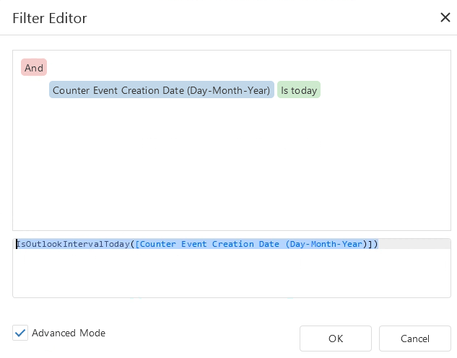

Now the chart will display today’s counters only.

**Tip:** If you see an empty chart, it could be for two reasons:

1. The refunds bot has not incremented the counters. Check the code using the debugger.
2. You have incorrectly defined the filter.

**Save Dashboard**

Click on Viewer:



Press *Save*. Now the dashboard can be viewed by other users.

## Export Dashboard to PDF

In view mode, click the  icon. This will give you three options to export the dashboard. Choose Pdf:

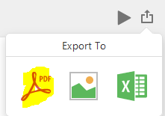

Select the default options:

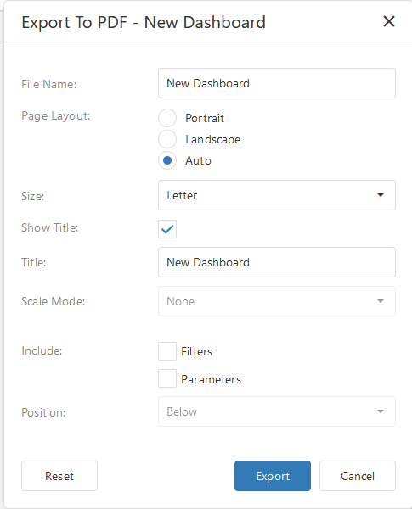

Press Export. Set the *Save File* option and press *OK*.

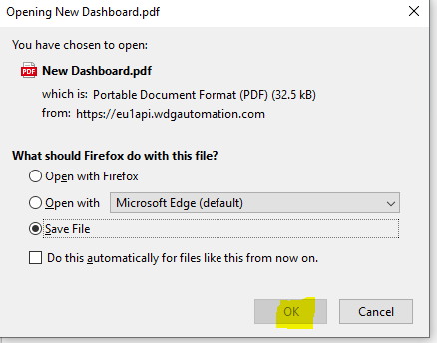

The pdf is saved to your local drive where it can be shared with the business.

Nicely done! This concludes the lab.